**BÀI TẬP VỀ NHÀ**

**MÔN KỸ THUẬT ROBOT**

Họ tên: Nguyễn Thanh Văn

MSSV: 20146181

**Bài 4.1:**

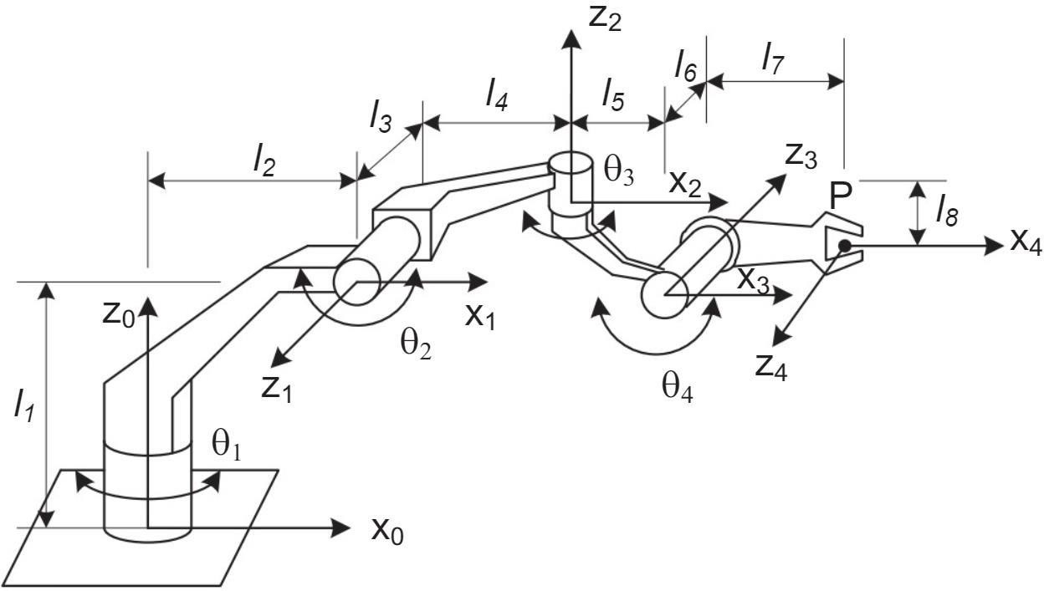

Bảng tham số D-H:

|  |  |  |  |  |  |
| --- | --- | --- | --- | --- | --- |
| Khớp | 𝜃 | 𝛼 | 𝑙 | 𝑑 | 𝑣𝑎𝑟 |
| 1 | 𝜃1 | 𝜋  2 | 𝑙2 | 𝑙1 | 𝜃1 |
| 2 | 𝜃2 | − 𝜋  2 | 𝑙4 | 𝑙3 | 𝜃2 |
| 3 | 𝜃3 | − 𝜋  2 | 𝑙5 | 𝑙6 | 𝜃3 |
| 4 | 𝜃4 | 𝜋 | 𝑙7 | 𝑙8 | 𝜃4 |

**Bài 4.2:**

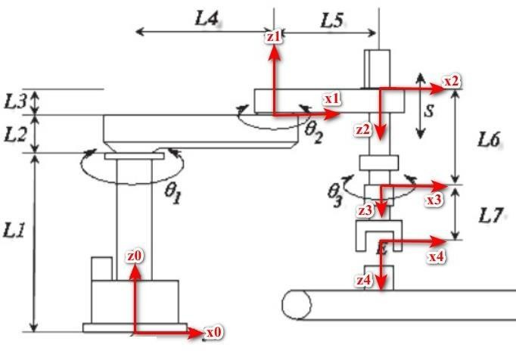

Bảng tham số D-H:

|  |  |  |  |  |  |
| --- | --- | --- | --- | --- | --- |
| Khớp | 𝜃 | 𝛼 | 𝑙 | 𝑑 | 𝑣𝑎𝑟 |
| 1 | 𝜃1 | 0 | 𝑙4 | 𝑙1 + 𝑙2 | 𝜃1 |
| 2 | 𝜃2 | 𝜋 | 𝑙5 | 𝑙3 | 𝜃2 |
| 3 | 0 | 0 | 0 | 𝑙6 + 𝑠 | 𝑠 |
| 4 | 𝜃2 | 0 | 0 | 𝑙7 | 𝜃2 |

**Bài 4.3:**

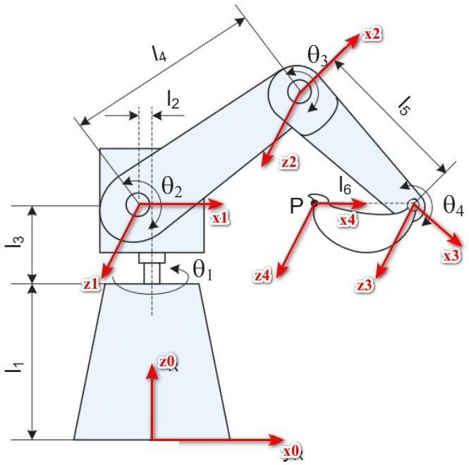

Bảng tham số D-H:

|  |  |  |  |  |  |
| --- | --- | --- | --- | --- | --- |
| Khớp | 𝜃 | 𝛼 | 𝑙 | 𝑑 | 𝑣𝑎𝑟 |
| 1 | 𝜃1 | 𝜋  2 | 𝑙2 | 𝑙1 + 𝑙3 | 𝜃1 |
| 2 | 𝜃2 | 0 | 𝑙4 | 0 | 𝜃2 |
| 3 | 𝜃3 | 0 | 𝑙5 | 0 | 𝜃3 |
| 4 | 𝜃4 | 0 | 𝑙6 | 0 | 𝜃4 |

**Bài 4.4:**

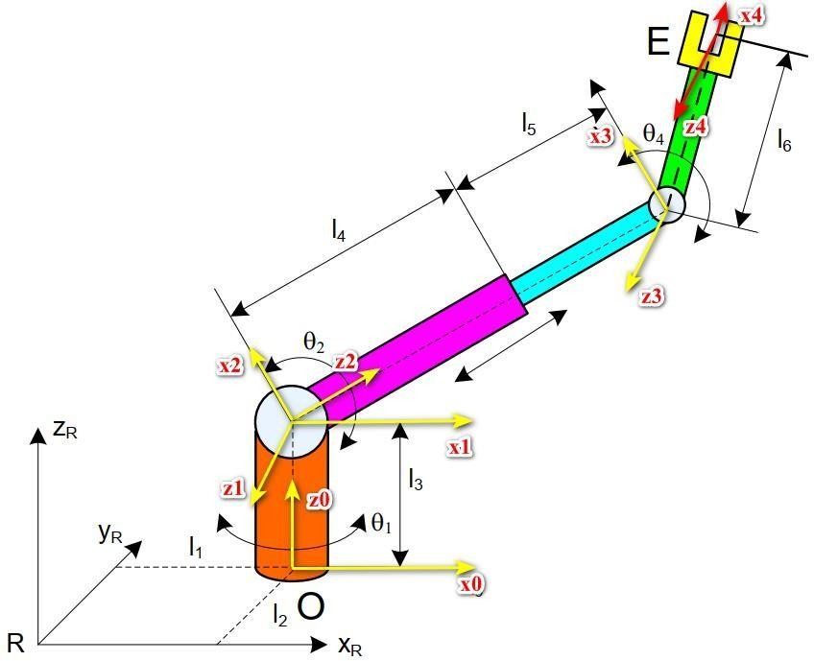

Bảng tham số D-H:

|  |  |  |  |  |  |
| --- | --- | --- | --- | --- | --- |
| Khớp | 𝜃 | 𝛼 | 𝑙 | 𝑑 | 𝑣𝑎𝑟 |
| 1 | 𝜃1 | 𝜋  2 | 0 | 𝑙3 | 𝜃1 |
| 2 | 𝜋  𝜃2 + 2 | 𝜋  2 | 0 | 0 | 𝜃2 |
| 3 | 0 | − 𝜋  2 | 0 | 𝑙4 + 𝑙5 | 𝑙5 |
| 4 | 𝜋  𝜃4 + 2 | 0 | 𝑙6 | 0 | 𝜃4 |

**Bài 4.5:**

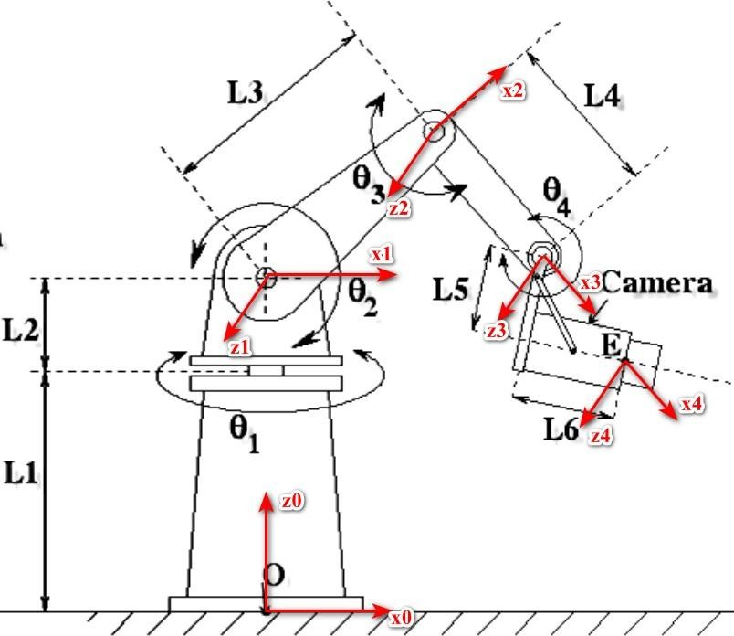

Bảng tham số D-H:

|  |  |  |  |  |  |
| --- | --- | --- | --- | --- | --- |
| Khớp | 𝜃 | 𝛼 | 𝑙 | 𝑑 | 𝑣𝑎𝑟 |
| 1 | 𝜃1 | 𝜋  2 | 0 | 𝑙1 + 𝑙2 | 𝜃1 |
| 2 | 𝜃2 | 0 | 𝑙3 | 0 | 𝜃2 |
| 3 | 𝜃3 | 0 | 𝑙4 | 0 | 𝜃3 |
| 4 | 𝜃4 | 0 | √𝑙2 + 𝑙2  5 6 | 0 | 𝜃4 |

**Bài 4.6:**

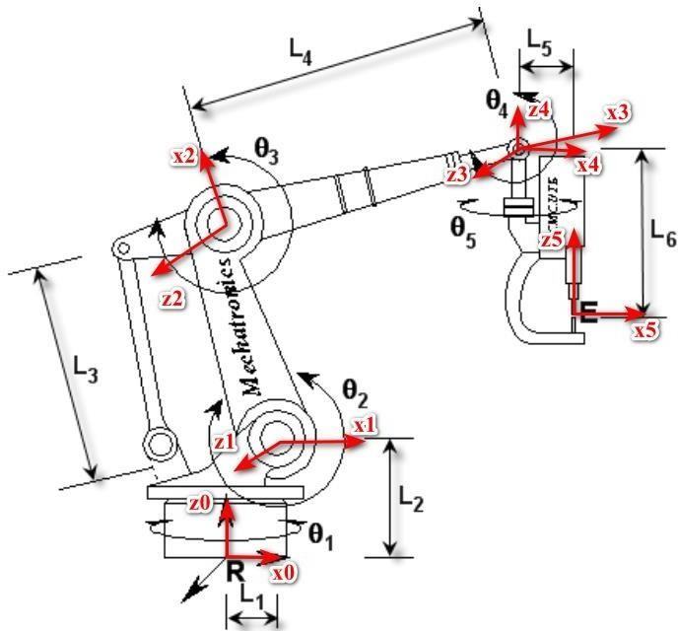

Bảng tham số D-H:

|  |  |  |  |  |  |
| --- | --- | --- | --- | --- | --- |
| Khớp | 𝜃 | 𝛼 | 𝑙 | 𝑑 | 𝑣𝑎𝑟 |
| 1 | 𝜃1 | 𝜋  2 | 𝑙1 | 𝑙2 | 𝜃1 |
| 2 | 𝜃2 | 0 | 𝑙3 | 0 | 𝜃2 |
| 3 | 𝜃3 | 0 | 𝑙4 | 0 | 𝜃3 |
| 4 | 𝜃4 | − 𝜋  2 | 0 | 0 | 𝜃4 |
| 5 | 𝜃5 | 0 | 𝑙5 | 𝑙6 | 𝜃5 |